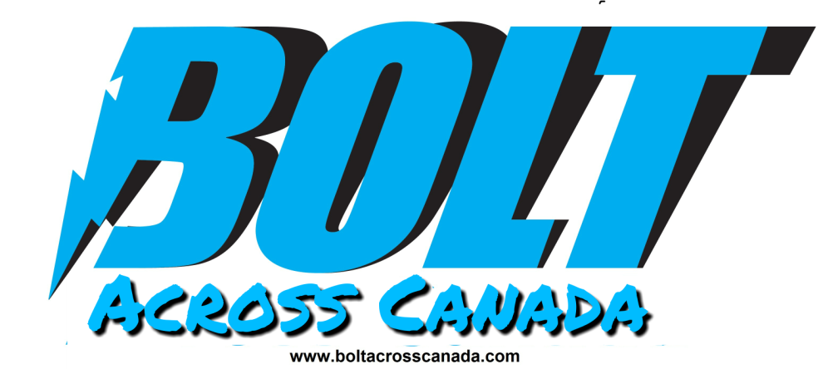

For Immediate Release: June 5 2017 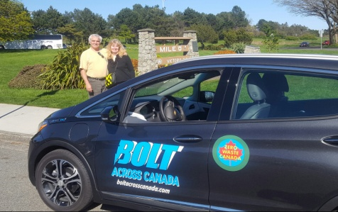
Contact: Buddy Boyd
Bolt Across Canada/ Zero Waste Canada

604-740-1425
boltacrosscanada@gmail.com
Zero Waste Canada launches Bolt Across Canada tour to promote Zero Waste and zero emissions.
Zero Waste Canada will launch the Bolt Across Canada tour to promote Zero Waste and zero emissions in Victoria BC on July 1st 2017 at James Bay Anglers boat ramp (75 Dallas Road).At 9 am. Buddy Boyd and Barbara Hetherington, two of the directors of the grassroots non-profit organization Zero Waste Canada will be dipping the wheels of their all electric Chevy Bolt into the water on the Victoria shoreline as they begin their odyssey across Canada (from coast to coast) as they raise green awareness.
Mayor Lisa Helps will be in attendance to see the couple off on their road trip.
“Victoria is the perfect location to launch Bolt Across Canada not only because it is Mile Zero but because Victoria is a vibrant community adopting more sustainable lifestyle choices. There are over 100 electric vehicle charging stations located in the Capital Region District and more and more residents are switching to electric vehicles. The local electric vehicle associations give a welcoming and supportive network for those thinking about low emissions driving. Plus in the area there is a growing community of individuals and businesses creating Zero Waste lifestyles and solutions,” says Barbara Hetherington.
Buddy Boyd adds, “As we as Canadians reflect on Canada’s history as we work on healing with our Reconciliation efforts and as we celebrate the Confederation of Canada, we must also look towards the future. Climate change is a real threat that is having a devastating impact on the future of our planet and our country. The good news is that regular Canadians can make a difference. Simple lifestyle choices like reducing waste and consumption, and making wiser vehicle choices do have a positive impact. We want to promote our emerging green highways and roads that are making it easier for more and more Canadians to drive low emissions vehicles and we want to take the message that Zero Waste, one of the quickest, easiest and most effective first steps for individuals and communities, to immediately reduce GHG emissions.”
The couple plans to be on the road with Bolt Across Canada for two months as they visit communities across Canada. As they travel throughout Canada, they will be showing it is possible to have a low impact road trip in an electric vehicle.
Bolt Across Canada will be blogging about their experiences crossing Canada as well as telling the stories of regular Canadians making a difference. Readers can follow the road trip also on social media.
From Victoria Bolt Across Canada will be heading towards the south central area of British Columbia.
Bolt Across Canada will be launching the beginning of the two month road trip on July 1, at James Bay Anglers boat ramp (75 Dallas Road) at 9am.
